Where should I put my files? How to name my layout files?
Please have a look at the file: Project Folder Structure.docx.

Database Structure?
Please check the file: Database Structure.txt.
It is my first version; you can change it.

The default account
All users except customer users require approval. But we have four default accounts in the system. All of them have been approved. You can use them for approved development. You can register more for unapproved development.
Admin account:
Email: Amelie@gmail.com
Password: 111111
Customer account:
Email: Sifa@gmail.com
Password: 111111
Supplier account:
Email: Ike@gmail.com
Password: 111111
Service account:
Email: Daniel@gmail.com
Password: 111111

About the default Header
I have developed the general Header, you can use it by inheriting your Activity from BaseActivity. It’s a screenshot:
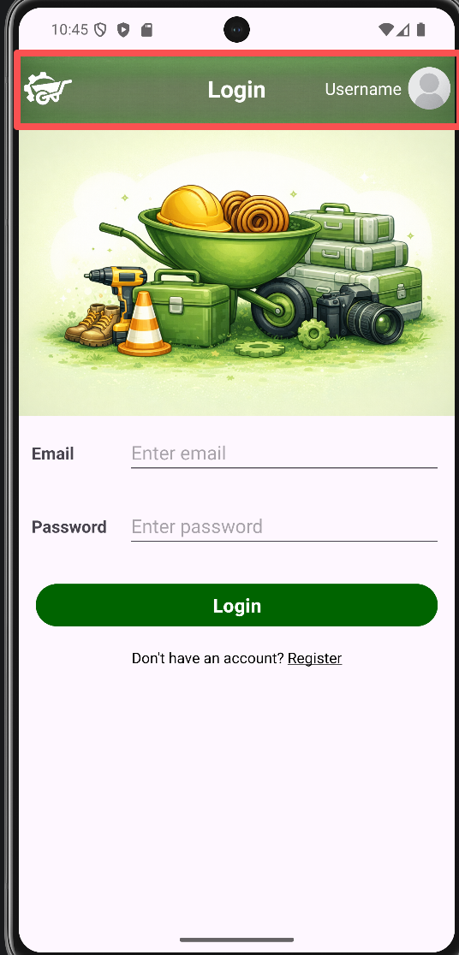
Clicking the Logo image will navigate to the related dashboard. Clicking the Avatar image will go to the login page or a menu with Profile and Logout items. If you have logged in, it will show your username to the left of the Avatar. Also, you can change the title by invoking the method from BaseActivity.

In your layout file, you should include the layout_common_header element at the top of the file.
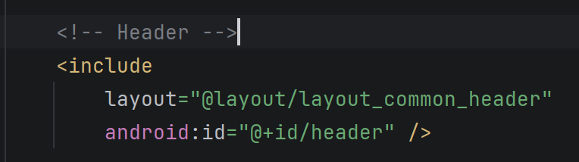
If you do not like it, you can add your own Header.

Unified button style
Add style="@style/AppButtonPrimaryStyle" to your button.
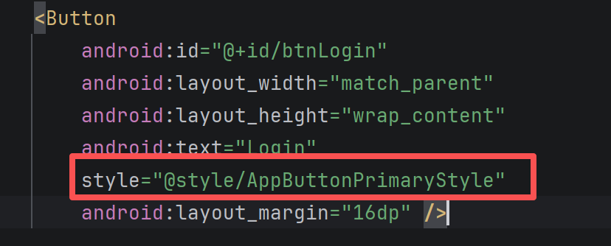

About Firebase
We use Firebase Realtime database.
Email+Password for Authentication, because it is easier.
We do not use Storage to store Images, because it asks me to bind cards. We use a shared website: cloudinary.

Database operation code
Constant define:
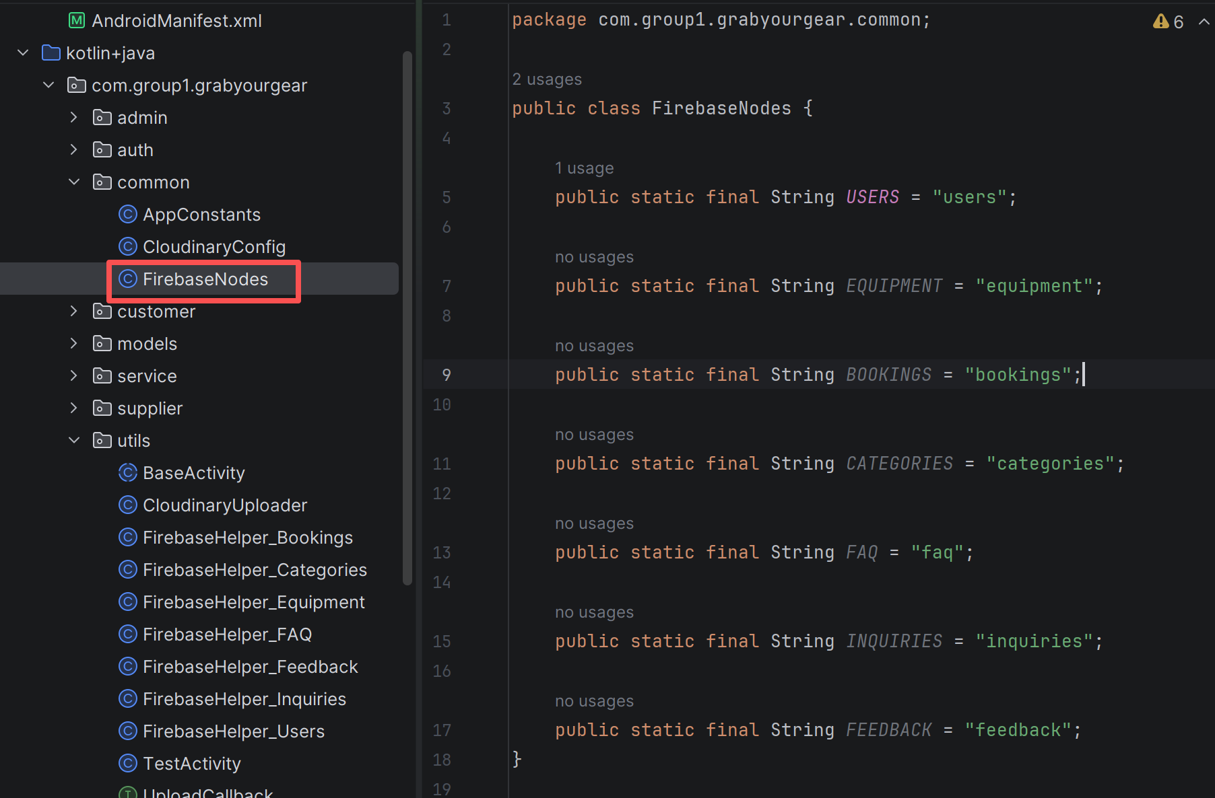
Please write your CRUD code in the related file.
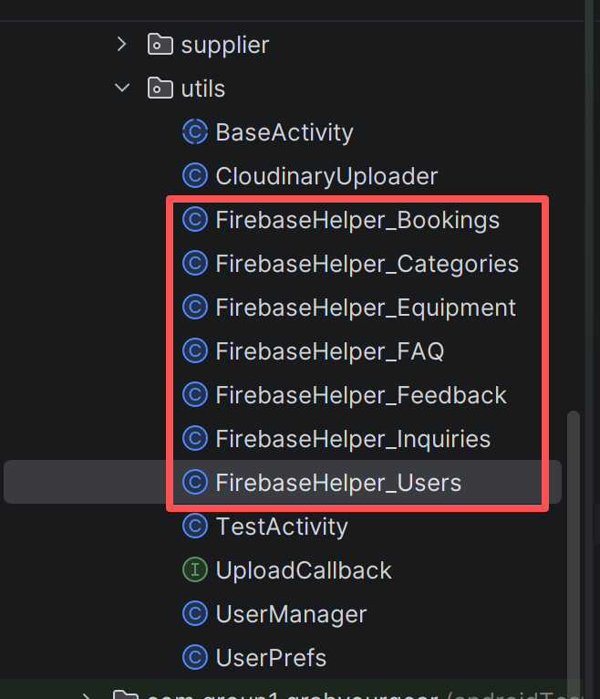

How to upload image and show it?
I have written a class CloudinaryUploader to deal with images. You can use it to refer to the example: TestActivity.
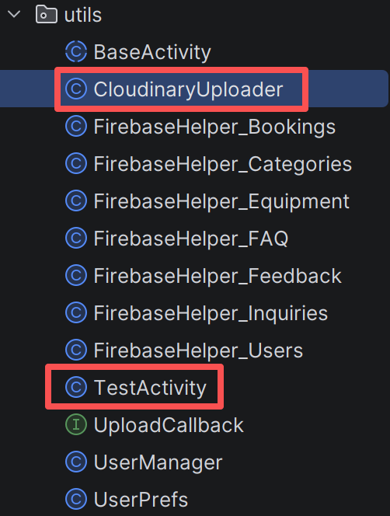

How to upload images to Android emulator?
- Go to path: %LOCALAPPDATA%\Android\Sdk\platform-tools
- Shift + right click to select Open PowerShell here.
- run:
.\adb devices //it will show your emulators.
.\adb push "YourPicturePath" /sdcard/DCIM/ // replace “YourPicturePath”

